DOCUMENTATIION OF SOFTWARE

SSENTONGO ANDREW 16/U/1152

AYEBARE MAXWELL BARIYO 16/U/4015/PS

MURUNGI CHRISTOPHER 16/U/701

MUJAMBULA LINCOLN 16/U/7415/PS

KIBENGE SHAFIC 16/U/5915/PS

USER GUIDE

Overview .

The importance of the user manual is to guide the user on how to use the software program .

HOW TO RUN THE SOFTWARE

Open the Trial.java class in Netbeans JDK and run the file.

When the program is run the output is as shown below;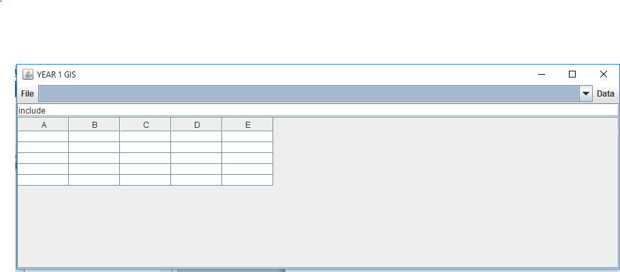

File menu

Under this menu the following buttons are available;

* Open shapefile
* Open MapContext
* Create Shapefile

1. Open shapefile

This button opens a dialogue box for the user to select a shapefile file to query data from.

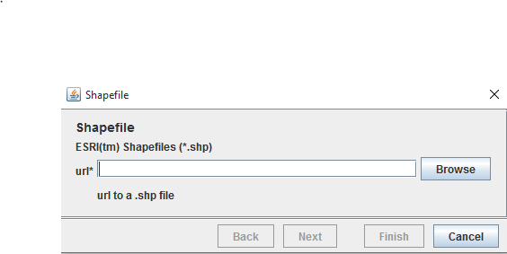

1. Open MapContext

This button opens a new window where you can add vector and raster data from.

Also under this you can add coordinate transformation systems.

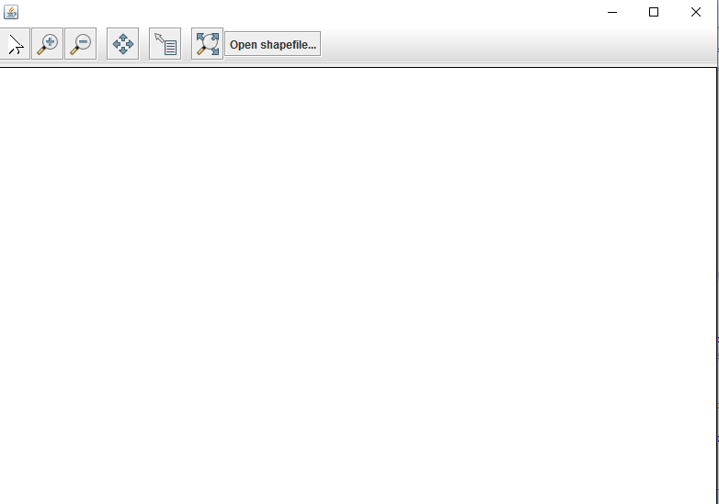

Under this window we have different buttons;

1. The pointer arrow.

This is used to select a given point.

C:\Users\SANTOS CLAVO\Pictures\capture8.PNG

1. Zoom in .

This button is used to enlarge a specific part of an image.

C:\Users\SANTOS CLAVO\Pictures\Capture9.PNG

1. Zoom out

This button is used to minimise the size of the image.

C:\Users\SANTOS CLAVO\Pictures\Capture10.PNG

1. Identify pointer

This button is used identify features on different layers

C:\Users\SANTOS CLAVO\Pictures\Capture13.PNG

1. Extent button

This button is used to zoom to full extent of the layers

C:\Users\SANTOS CLAVO\Pictures\Capture16.PNG

1. Open shapefile

This button is used to import a shape file from a given location.

C:\Users\SANTOS CLAVO\Pictures\Capture18.PNGC:\Users\SANTOS CLAVO\Pictures\Capture14.PNG

g. Export shapefile

This button is used to export a shapefile with the correct coordinate reference system.

1. Create shapefile

This button creates a shapefile from a CSV.

This button opens window where the CSV file is opened from.

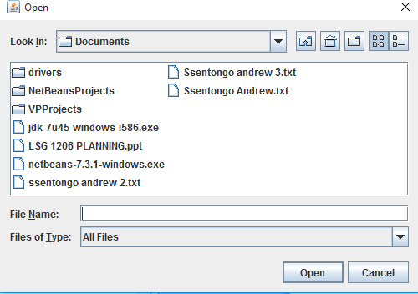

Data

This are the following buttons that are present within the data menu;

* Get features
* Count

1. Get features

This button is used to query all features after opening a shapefile.

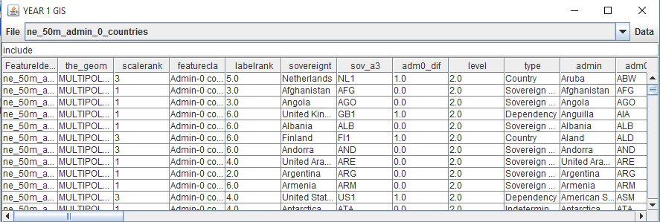

1. Count

This button is used to count the available features.

